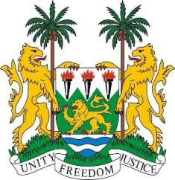
SIERRA LEONE
27th Session of the UPR

ALGERIA

9 May 2017
Mr President,

Sierra Leone warmly welcomes the distinguished delegation from Algeria to this review cycle and thanks them for their presentation.

My delegation commends Algeria for implementing various strategies to better promote and protect human rights nationally, including the national action plan aimed at child protection, health and quality education.

Sierra Leone further notes that since its last UPR, the constitutional amendments of 2016, which led to several improvements in the legal system, including to the judiciary, as well as to constitutionalising the national human rights institution.

My delegation would encourage the government to continue to work with UNHCR for the effective registration of the Saharawis living in precarious conditions.

Recommendations:

1. Ratify the ICPPED and the Optional Protocols to the CEDAW and the CRPD.
2. Safeguard rights of religious minorities through institutionalizing inter-religious dialogue.
3. Further empower the socioeconomic development of the regions inhabited by the Amazigh peoples.
4. Intensify efforts to provide appropriate vocational training and employment of youths.
5. Develop a national policy to address trafficking in person.

In conclusion, Sierra Leone wishes Algeria every success in this third review cycle.

Thank you, Mr President.

